Artificial Intelligence & Robotics – Synthetic Brain in Action

Student Name

Course Information
Professor’s Name
University Affiliation
Assignment Due Date

Artificial Intelligence & Robotics – Synthetic Brain in Action

Abstract
Rapid technological growth has made Artificial Intelligence (AI) and application of robots common among human lives. The advancements undertaken to make designs with human similarities or adaptations to the society are elaborated in detail. The increasing manufacturing and use of robots for industrial purposes have been related to their operating mechanisms. The experiments and laboratory testing of these devices is analysed in form tables to show the statistical side of the technology. This report explains the technological aspects and laboratory experiments that have been advanced to increase knowledge on these digital technologies. This study aims to present an overview of two developing technologies: artificial intelligence (AI) and robots and their potential applications. The product variety is a primary characteristic of each of these specialties. In addition, they may be described as disruptive, facilitating, and transdisciplinary.
Keywords

Artificial intelligence, Robots, & Trust Game
1. Introduction
Soon, digital technologies such as Artificial Intelligence (AI) and robots will have a substantial influence on human growth. There are basic problems regarding what we should do with these systems, what they should do, and how we can regulate them. This is only a hypothesis at this point according to Ezrachi et all. (2017). Programming computers to perform tasks that would otherwise need human Intelligence. Only a few examples include visual perception, speech recognition, decision-making, and translation across languages. The " actor " begins in the software and culminates in the hardware body called the "base object." They are linked because software agents drive robots, read sensor data, decide what to do next, and then instruct the effectors to carry out that action according to Kumar (2018).
2. Background Information of the Two Emerging Technologies
Intelligent behaviour may be described as complicated behaviour that helps an artificial computer system achieve its objectives, and this is what is meant by "artificial intelligence" (AI). "Intelligence," as highlighted by Minsky, is not a phrase that can be applied simply to things that need human thought (1985) according to Andreu-Perez et all (2018). While "technical AI" systems, which cannot learn or reason, are included, so are "general AI" systems, which attempt to develop a general intelligent agent according to Spiegeleire et all (2018).
AI is more pervasive in our everyday lives than any other technology has led to the emergence of an academic discipline called "AI philosophy." As humans, we see these traits as innate, and AI's ultimate goal is to create computers that can similarly show these traits as we do according Lu et all (2018). An artificially intelligent creature is expected to do tasks such as perceiving, text analysis, natural language processing (NLP), logical reasoning and gaming according Irfan et all (2018). AI is also being applied in decision support systems, self-driving vehicles, and other types of robots according to Bryndin (2019). These goals may be achieved using a variety of computational approaches, such as classical symbol manipulation AI inspired by natural cognition and machine learning using neural networks according to Gonzalez et all (2019).
Robots, on the other hand, are physical machines that can move. Robots using "actuators," such as grippers or rotating wheels, exert physical force on the environment, while robots are vulnerable to physical impact through "sensors." Robots are thus autonomous vehicles or aircraft, with the exception of the "humanoid" (or human-shaped) ones that appear in movies according to liang et all (2017). AI is used by certain robots, but not all of them: Typical industrial robots are programmed to obey a predetermined set of instructions with limited sensory input and no ability to learn or reason according to Liu et all (2020). Despite the public's anxieties about robots, it's conceivable that AI systems will have a bigger influence on the human race. It is less probable for robots and AI to cause difficulties if intended to do certain jobs rather than being more open and autonomous according to Nguyen et all (2019). Three types of systems exist solely artificial intelligence systems, simply mechanical systems, and systems that are both according to Ghahramani et all (2015). Additionally, this article focuses on the union of the two sets, not only their intersection.
2.1. Measuring Trust on Robots with a Trust Game.
The trust game is a test to see whether investing choices are influenced by a person's level of trust. According to according to Ghahramani et all (2015), trust and reciprocity are measured in an economic exchange connection through the investment game. Research has shown that people's desire to reciprocate trust is influenced by both their own personal interests and the repercussions for others according to Bryndin (2019). The amount of money that players are prepared to give up determines the results of trust in the trust game.
This research employed an experimental trust game concept to see whether participants trusted robots and AI. When it comes to robots and artificial intelligence, do participants have a lower level of faith in them than they do in other members of the group? In the trust game, opponents were altered to be either robots or AI according to Bryndin (2019). Only human names or nicknames were used to compare them to the control group opponents. It was preregistered at the Open Science Framework before any data was gathered.
3. Procedure for Robot-Related Variables
Additionally, various factors pertaining to robotics were examined in the study's second section. "Have you heard, read, or seen anything concerning robots in social media, internet forums, or blogs?" (No/Yes). On the basis of the RUSH-3 scale, three statements were incorporated on a scale ranging from 1 (strongly disagree) to 7 (strongly agree) (strongly agree). As part of this research, the following statements were used: (a) "I am sure that I can learn how to operate robots." B) "I believe I can master the basic programming of robots if I'm given the proper instruction," he said. in addition to (c) "I am confident in my capacity to learn how to utilize robots in order to teach others how to do the same." Cronbach's alpha (α = 0.88) indicated that the measure was reliable, and the final total variable varied from 3 to 21. A single question asked participants whether they had ever used or interacted with a robot in the past.
A 15-item Big Five assessment was used to examine personality characteristics in the second half of the research, with participants grading statements from one to seven. We generated a 3-item sum variable with a range of 3–21 for each personality feature. For neuroticism (α = 0.85), extraversion (α = 0.84), openness (α = 0.79), agreeability (α = 0.62), and conscientiousness (α = 0.67), the interitem reliability was excellent to adequate.
3.1. Statistical Techniques
Stata 16 was used for all of our analyses. We opted to utilize parametric one-way and two-way ANOVAs since our sample size was big (N = 1077) and the violation of normality was modest. Larger samples do not have an issue with negative kurtosis. In addition, the size of the experimental and control groups was similar. It was also shown that the experiment and control groups had the same variance (2according Lu et all (2018) = 2.75, p = 0.739) using Bartlett's test for equal variance. A non-parametric Kruskal–Wallis H test was used to verify the data's robustness. Only the parametric one-way and two-way ANOVA tests are included in this report since these findings did not deviate from the parametric testing.
Ordinary least squares regression was used in the study's second section. R2 and R1 values, p-values, R2 goodness-of-fit metrics, model test results, and the standard errors of the regression coefficients were presented. Multicollinearity was not found to be a concern. Relative heteroskedasticity was not a concern (2 = 0.65, p = 0.42), according to the Breusch–Pagan test for heteroskedasticity. It was also assumed that residuals (skewness = 0.22, kurtosis = 0.237, where 3 = normal distribution) were distributed normally. There are a few things to keep in mind while searching for outliers in Cook's distance measure. We also ran the model using a robust regression because of the existing outliers, which is regarded a solution in circumstances when outliers occur.
4. Results
Table 1 and Figure 1 reveal that the opponent known as "jdrx894, a robot" received the most money on average, while the opponent known as "Michael" received the least money. [F (5,1071) = 3.17, p = 0.008] demonstrated statistically significant differences across groups in the one-way ANOVA findings. Jdrx894 robot (M = 540.33) got more money than Michael (M = 415.95, p = 0.003) in the control group in a pairwise comparison of means using Tukey's honest significant difference test.
Table 1. Money received by experimental groups.
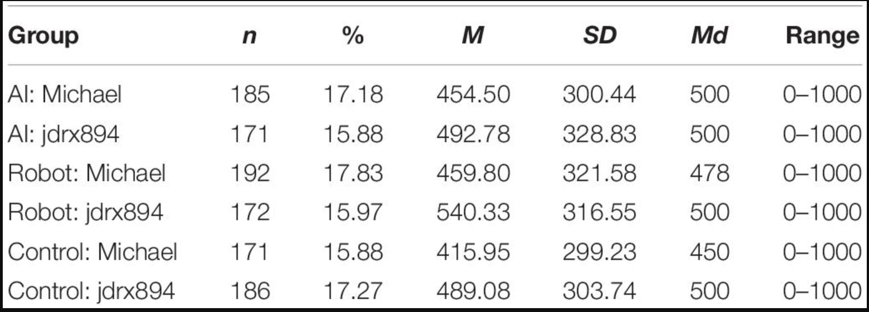
Graph 1. Shows the interval plot of the money given by the experimental groups.
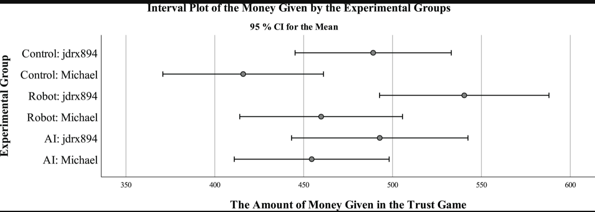
Both the name (Michael or jdrx894) and the kind of opponent (robot, AI, or control) were examined in a two-way ANOVA (see Table 2). None of the three categories of opponents had statistically significant differences. An F (1,1071) of 11.31 indicates that those who were named Michael were less trusted than those who were not. According to the ANOVA model's adjusted averages, jdrx894 was awarded $507.40 but Michael was only awarded $444.42.
Table 2. Examination outcomes of the name and the kind of opponent.
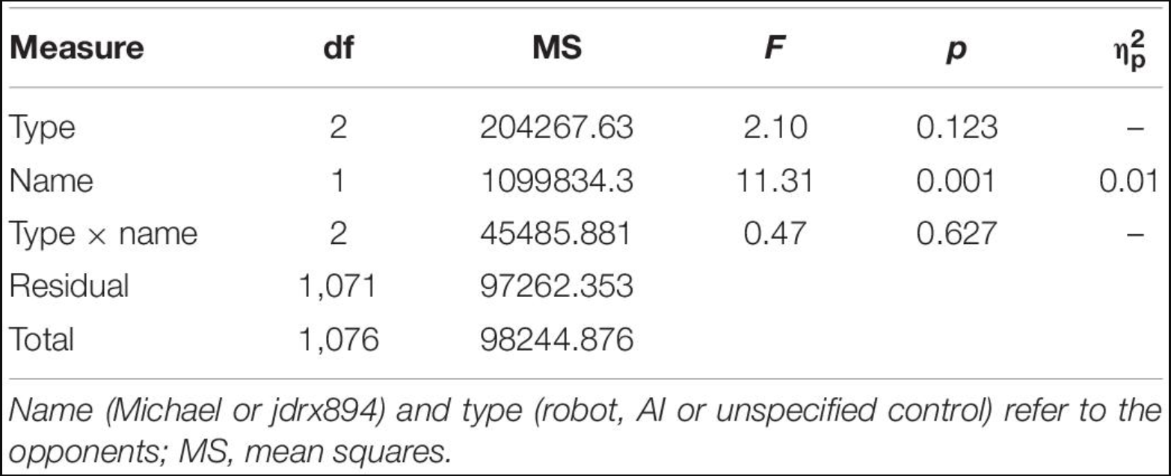
The second part of the study looked at the relationships between the level of confidence people have in robots and artificial intelligence (n = 720 participants). Because prior analyses indicated no statistically significant differences between participants in the robot and AI scenarios, the researchers pooled the two groups. There were no statistically significant interactions between conditions in regression models. $485 (M = 485.51, SD = 318.00, range $0–$1,000) was the average amount of money paid to the robot or AI opponents. There are no control groups in Table 3 since they were not employed in the second phase of analysis. It was clear that the participants were not all alike. Engineers and technologists, on the other hand, contributed an average of $530, while the public contributed an average of $471. Table 4 shows the regression model's findings on the variables linked with donating money to an opponent in terms of sociodemographic and social–psychological components. There was a statistically significant model (R2 = 0.09, F = 4.90, p = 0.001), and the included factors explained 9 percent of the variation.

Table 3. Shows categorical and continuous measures
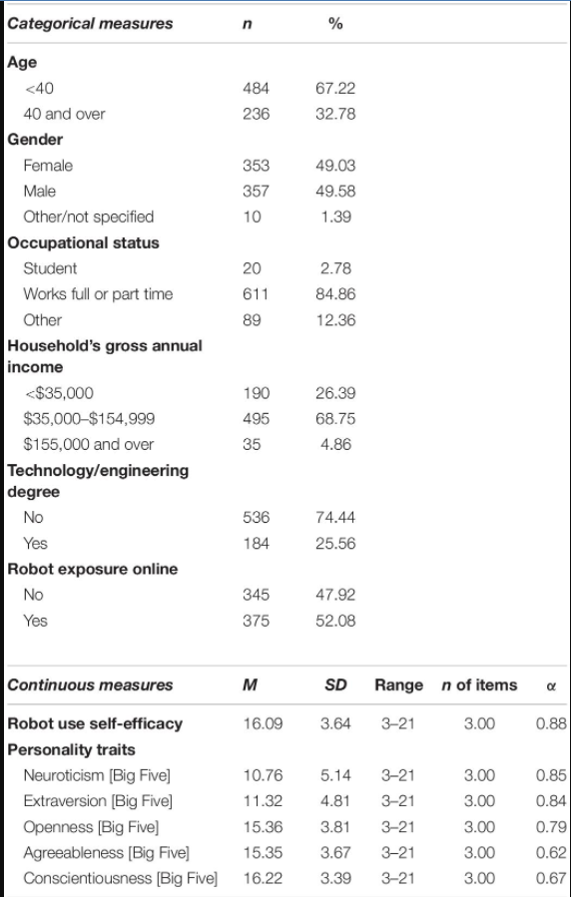

Table 4. Shows comparison among different groups.
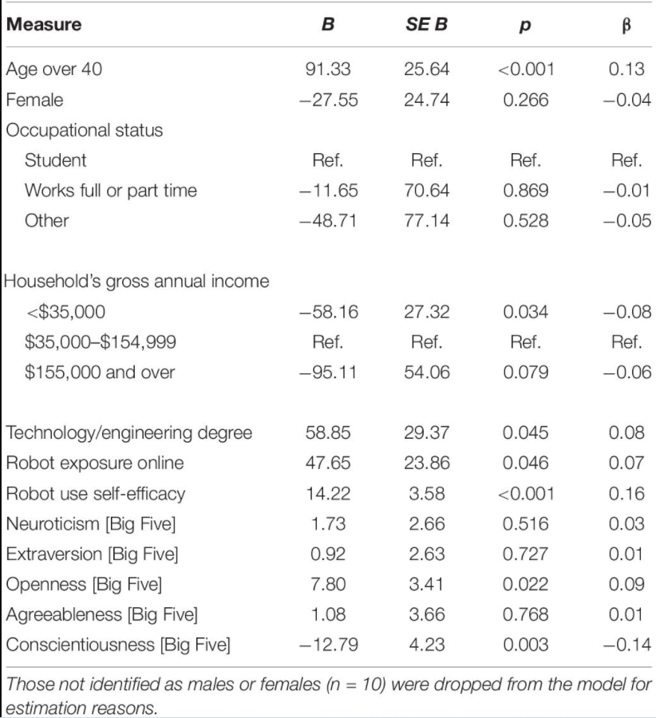
If you're over 40 and have a technology/engineering degree, you're more likely to give money to robots and AI than someone who is younger (α = 0.13, p = 0.001). Participants in both the low- and high-income groups contributed much less money to the robot and AI opponents, as was also seen. When comparing families with a gross yearly income of less than $35,000, we discovered statistical significance (α = 0.08, p = 0.034) exclusively in the $35,000–$154,999 income category.
The study also found that those who had been exposed to robots online contributed greater money to robots and AI opponents (α = 0.07, p 0.046). Robot usage self-efficacy (α = 0.16, p 0.001) was the single most significant predictor of providing money to an AI or robot as explained by Oksanen (2020). Extrovertist and agreeableness were not statistically significant personality qualities. As a result, people who are open to new experiences give more money to robot or AI opponents (α = 0.09, while those who are conscientious give less money (α = -0.14, respectively).
The final model was used to investigate the possible consequences of earlier exposure to robots. Many participants (33.19 percent) said they'd had such a recollection. The model now includes an interaction term between robot experience and robot self-efficacy. R2 = 0.10, F = 4.60, p 0.001 showed that the model was statistically significant, and 10% of the variation was explained as explained by Oksanen (2020). That which was statistically important in the prior model was shown to remain so. Noting past experiences with robot usage had no effect on the outcomes. The interaction term, on the other hand, was negative (α = 0.40, p = 0.038), showing that persons with prior experience with robots and strong self-efficacy in robot usage awarded lesser quantities of money to AI and robot opponents.
5. Discussion and Conclusion
According to this research, it's important to teach students about AI before they begin working with it (AI). There were thus hopes for precise predictions of how these technologies will affect people's lives in the future. It's impossible to make any conclusions from this viewpoint since these firms are so dynamic and ambiguous as explained by Yao et all. (2015). The incorporation of AI (Artificial Intelligence) is an essential part of Robotics. Many business processes can be automated with the use of artificial intelligence (AI) and robots (ROS). Trust is an important factor in human–technological contact, as well. As part of our research, we used a trust game to examine how much participants trusted robots or AI. The sort of opponent (robot, AI, or not stated control) had no significant impact on trust, contrary to our assumptions according Irfan et all (2018). There was greater faith in the opponents called Michael than the ones named jdrx894. The robot jdrx894 was the most trusted adversary, while Michael from the control group was the least trusted.
The study also concluded that confidence in robots and AI was influenced by technological education, online exposure to robots, and self-efficacy in robot usage. According to prior study, user experience and familiarity with robotics as well as robot usage self-efficacy are critical to the success of robots. It's possible that being exposed to online debates improves one's sense of trust. However, due to a dearth of previous studies, this issue warrants more investigation. However, the potential influence of online groups and conversations has already been documented.
Our findings also demonstrate the importance of personality in comprehending human–technological relationships and the trust that develops between the two. We discovered evidence for a favourable association between openness and trust toward robots and AI, which is in keeping with earlier studies on personality variables and trust in general. In contrast to their findings, our data show that conscientiousness has a negative correlation with confidence in robots and AI. There was no correlation between agreeableness, extraversion, or neuroticism and these qualities.
The findings make sense in light of the fact that humans have gotten increasingly used to robots over time. The image of AI may be more abstract and distant, but comparable design efforts have been attempted to combine AI bots with humanlike virtual visuals. Robots, on the other hand, have been created to be more appealing, accessible, and predictable based on, for example, gestures. When it comes to trusting a robot named jdrx894, visual mental imagery has been shown to have a significant impact on how people view robots. Participants in the experiment had the least faith in Michael, the guy in charge of the control group, according to the findings. Studies have shown that individuals tend to see others as more selfish and negative than they really are, which may explain this phenomenon. Because of these factors, our participants may have been more open to trusting robots. This contradicts the idea of similarity–attraction. Gender is also a factor. Only one other participant in our study was a man called Michael. Males are often seen as less trustworthy than females when it comes to economic game trials.

References List
Andreu-Perez, Javier, Fani Deligianni, Daniele Ravi, and Guang-Zhong Yang. 2018. “Artificial Intelligence and Robotics.” ArXiv:1803.10813 [Cs], March. http://arxiv.org/abs/1803.10813.
Bryndin, Evgeny G. 2019. “Robots for Communication in Public Life in High-Tech Industry and Space,” January. https://www.academia.edu/40202614/Robots_for_Communication_in_Public_Life_in_High_Tech_Industry_and_Space.
Bryndin, Evgeniy. 2019a. “Collaboration Robots with Artificial Intelligence (AI) as Digital Doubles of Person for Communication in Public Life and Space | Bryndin | Budapest International Research in Exact Sciences (BirEx) Journal.” 2019. https://bircu-journal.com/index.php/birex/article/view/473.

Ezrachi, Ariel, and Maurice E. Stucke. 2017. “Artificial Intelligence & Collusion: When Computers Inhibit Competition.” University of Illinois Law Review 2017: 1775.
Gonzalez Viejo, Claudia, Damir D. Torrico, Frank R. Dunshea, and Sigfredo Fuentes. 2019. “Development of Artificial Neural Network Models to Assess Beer Acceptability Based on Sensory Properties Using a Robotic Pourer: A Comparative Model Approach to Achieve an Artificial Intelligence System.” Beverages 5 (2): 33. https://doi.org/10.3390/beverages5020033.
Ghahramani, Zoubin. 2015. “Probabilistic Machine Learning and Artificial Intelligence.” Nature 521 (7553): 452–59. https://doi.org/10.1038/nature14541.

Irfan, Dr Mohammad, and Dr Pooja Kansra. 2021. Social Governance, Equity and Justice. Wizard Publisher.
Kumar, Yuvraj. 2018. “Artificial Intelligence & Robotics – Synthetic Brain in Action.” SSRN Scholarly Paper ID 3325115. Rochester, NY: Social Science Research Network. https://doi.org/10.2139/ssrn.3325115.
Lu, Huimin, Yujie Li, Min Chen, Hyoungseop Kim, and Seiichi Serikawa. 2018. “Brain Intelligence: Go beyond Artificial Intelligence.” Mobile Networks and Applications 23 (2): 368–75. https://doi.org/10.1007/s11036-017-0932-8.
Liang, Yuhua, and Seungcheol Austin Lee. 2017. “Fear of Autonomous Robots and Artificial Intelligence: Evidence from National Representative Data with Probability Sampling.” International Journal of Social Robotics 9 (3): 379–84. https://doi.org/10.1007/s12369-017-0401-3.
Liu, Jun, Huihong Chang, Jeffrey Yi-Lin Forrest, and Baohua Yang. 2020. “Influence of Artificial Intelligence on Technological Innovation: Evidence from the Panel Data of China’s Manufacturing Sectors.” Technological Forecasting and Social Change 158 (September): 120142. https://doi.org/10.1016/j.techfore.2020.120142.
Nguyen, Giang, Stefan Dlugolinsky, Martin Bobák, Viet Tran, Álvaro López García, Ignacio Heredia, Peter Malík, and Ladislav Hluchý. 2019. “Machine Learning and Deep Learning Frameworks and Libraries for Large-Scale Data Mining: A Survey.” Artificial Intelligence Review 52 (1): 77–124. https://doi.org/10.1007/s10462-018-09679-z.
Oksanen, Atte, Nina Savela, Rita Latikka, and Aki Koivula. 2020. “Trust Toward Robots and Artificial Intelligence: An Experimental Approach to Human–Technology Interactions Online.” Frontiers in Psychology 11. https://www.frontiersin.org/article/10.3389/fpsyg.2020.568256.
Spiegeleire, Stephan De, Matthijs Maas, and Tim Sweijs. 2017. Artificial Intelligence and the Future of Defense: Strategic Implications For Small- and Medium-Sized Force Providers. The Hague Centre for Strategic Studies.
Yao, Fei, Chengyu Zhang, and Wu Chen. 2015. “Smart Talking Robot Xiaotu: Participatory Library Service Based on Artificial Intelligence.” Library Hi Tech 33 (2): 245–60. https://doi.org/10.1108/LHT-02-2015-0010.
———. 2019b. “Robots with Artificial Intelligence and Spectroscopic Sight in Hi-Tech Labor Market.” 2019. https://www.oatext.com/robots-with-artificial-intelligence-and-spectroscopic-sight-in-hi-tech-labor-market.php.

